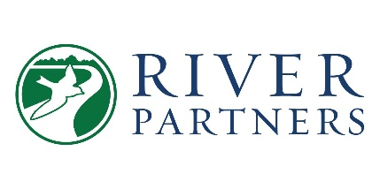

Media Highlights 2026
________________________________________________________________________________

A selection of notable media highlighting River Partners’ work, not a comprehensive list:

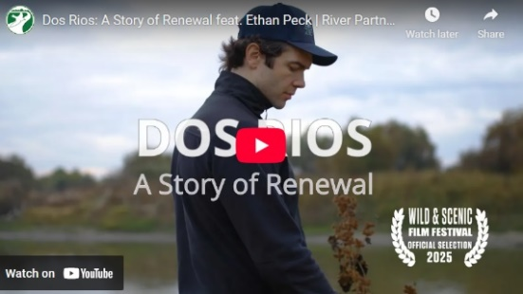
Wild & Scenic Film Festival, Official Selection, Dos Rios, A Story of Renewal
Actor Ethan Peck travels to California’s new state park at Dos Rios in the San Joaquin Valley to discover the importance of healthy rivers for California’s future, how ecosystem restoration is bringing healing to the nearby community of Grayson, CA, and the critical connection between the environment, Native California peoples, and their culture.

