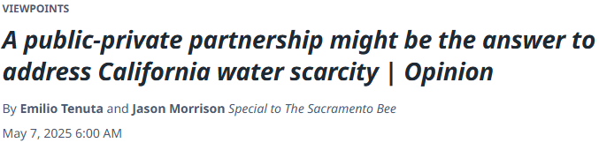

The California Department of Water Resources’ final snow survey showed that the state’s water supplies got a much-needed boost from an exceptionally wet March. Still, this is just a drop in the bucket compared to the state’s long-term water challenges. State scientists warn that California is on track to lose 10% of its water supply in the next 15 years due to warmer weather — a crisis that threatens our communities, businesses and ecosystems.

Not only does this mean less reliable water for growing food and running businesses, water scarcity increases our vulnerability to natural disasters. As extreme weather intensifies, securing and sustainably managing water resources will be critical to mitigating the impacts of prolonged drought, wildfire and flooding. That’s why business leaders are tapping in, with corporate stewardship activities aimed at helping secure California’s water future.

We have come together under the California Water Resilience Initiative, managed by the Pacific Institute, to accelerate collective action across sectors. As part of the Water Resilience Coalition, a global effort to mobilize corporate water stewardship, the California Water Resilience Initiative has a unique opportunity to lead both nationally and globally, defining the playbook for how businesses, government and non-profits can help build water resilience at scale.

The initiative has set a bold target: reducing, reusing and restoring one million acre-feet of water per year by 2030 — enough to meet the annual water needs of about 2 million California households. This goal supports statewide efforts to expand water supplies through conservation, recycling and storage.

This is not just talk: Corporate water stewardship is already delivering real impact on the ground. To date, nearly 175,000 acre-feet of water benefits have been achieved through corporate investments in 53 projects across the state. Many of these projects are funded through a combination of private and public funding, with corporations providing required match funds or helping to close a funding gap.

In Los Angeles and San Francisco, we are helping fix leaks and improve storm water capture in partnership with state and local agencies. In the Sacramento and Kern River watersheds, we are working with River Partners and Trout Unlimited to replenish habitats and restore ecosystems. In the San Joaquin Valley, we are helping small farms upgrade to water-wise irrigation infrastructure.

More projects are in the pipeline, including a school greening project in Central Los Angeles that will capture storm water and transform more than 30,000 square feet of pavement into a green schoolyard with native plants, trees and bioswales — reducing runoff, improving water quality and lowering flood risk. This project was primarily funded by the California Natural Resource Agency’s Urban Greening program, and corporate co-funding helped close the gap.

We recognize that building water resilience requires collaboration across sectors. Government alone can’t meet the scale of need, which is why we urge companies focused on the bottom line to take action. Public-private partnerships can unlock innovation and deliver lasting impact in water stewardship.

With the passage of Proposition 4, California has a historic chance to invest in water infrastructure, nature-based solutions and climate resilience.

Focusing on water projects that attract corporate investors will not only accelerate scaling efforts, it will also ensure water resource resilience for businesses and communities, sustaining their future growth. By blending public dollars with private action, we can make every project go further. Investing in water stewardship is smart business.

Water is essential to nearly every industry, and companies that take steps to secure their water future reduce operational risks, increase efficiency and strengthen supply chain resilience. Water shortages and disruptions can cost businesses millions in lost productivity, higher costs and regulatory challenges.

By adopting better water management practices today, companies can future-proof their operations, reduce costs and drive innovation.

Read more at: <https://www.sacbee.com/opinion/op-ed/article305419811.html#storylink=cpy>.