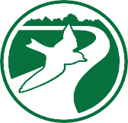



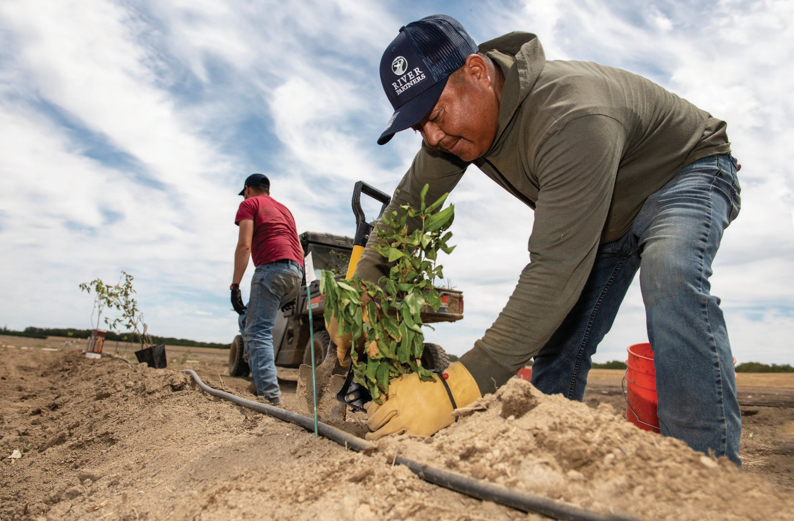

STATEMENT OF QUALIFICATIONS

## TITLE OF PROJECT/SUBHEAD DESCRIBING PROJECT

### May 1, 2024

*Prepared for:*

**Organization Name Address**

**City, State Zip**

*In response to:*

**RFQ-2023-01 On-Call Land Management Services**

# Executive Summary

River Partners is pleased to submit our Statement of Qualifications to the [PROJECT] in response to the Request for Proposals regarding [AGENCY].

Included in this SOQ are background about River Partners, our organizational capacity, breadth of services, and industry-leading restoration experience throughout California over more than a quarter- century. We have over 25 years of expertise in habitat restoration, enhancement, monitoring, and maintenance across a wide range of vegetation communities and habitat types.

River Partners has a proven track record of science-based restoration outcomes and wildlife co- benefits statewide.

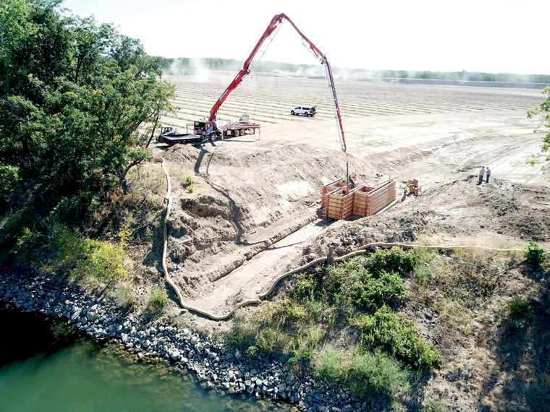

**In 2002, River Partners designed and constructed a first-of-its-kind fish bypass at our Willow Bend Preserve along the Sacramento River near Colusa. It allows endangered salmon access to historic feeding grounds during flooding along the river, as well as a way to exit the floodplain when floodwaters recede to continue their 300-mile migration between the Pacific Ocean to Shasta Dam instead of being stranded.**

# Identification of Contractor

* **River Partners leads California in restoring wildlife habitat for the benefit of the environment and people**
* **We’ve planted over 4 million trees and vegetation on nearly 20,000 acres throughout California over the last quarter-century**
* **We have the largest on-the- ground restoration footprint of anyone in the western U.S.**
* **We have proudly helped a range of federal and state agencies, corporations and other private entities, and NGOs meet their ambitious restoration and conservation goals**
* **Our team is comprised of leading experts in the restoration, science,**

**engineering, and operations fields**

For 25 years, River Partners has planned, implemented, and monitored native habitat restoration projects covering nearly 20,000 acres across California. With in-house expertise in restoration ecology, agriculture, finance, project management, and monitoring, we can take restoration projects to a higher level of efficiency and effectiveness. To date, we have planned and successfully completed more than 300 large-scale river restoration projects across 20 watersheds and tributaries, including the Sacramento-San Joaquin rivers system in the Central Valley, Otay River Valley in San Diego County, and the lower Colorado River.

**OUR VISION AND MISSION**

River Partners envisions interconnected, thriving ecosystems that sustain abundant wildlife, support productive farmland, preserve freshwater resources, enhance surrounding communities, and serve as the first line of ecological defense in a changing climate. Our mission is to bring life back to landscapes by creating native wildlife habitat for the benefit of people and the environment.

**WHERE WE WORK**

With the largest on-the-ground restoration footprint of any nonprofit organization or firm in the western U.S., River Partners revitalizes corridors from the northern Sacramento Valley to the US-Mexico border in some of the state’s most imperiled ecological areas.

**SOLUTIONS**

We restore thousands of acres of habitat annually to protect at-risk species, and deliver cost-effective, natural flood protection and water conservation benefits. Our pioneering solutions are at the forefront of California’s efforts to fight climate change and retain our state’s biodiversity, world-class industries, and quality of life.

**THE TIME IS NOW**

Together with our partners, River Partners has helped California emerge as a world leader in restoration practices that empower communities to bring life back to our riverways. Climate impacts and biodiversity loss force us to move faster and think bigger. River Partners is poised to accelerate the pace of restoration throughout the state in the next decade.

# Statewide Coverage & Experience

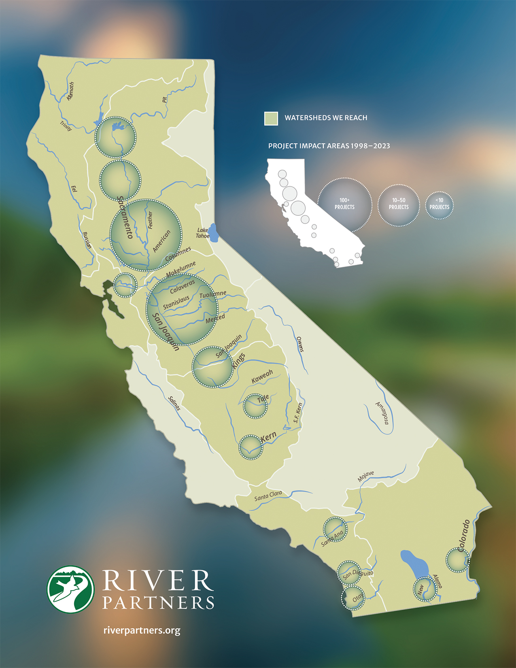Founded in 1998, River Partners has led hundreds of successful, landscape-level restoration projects on nearly 20,000 acres across California—from the Sacramento Valley to San Joaquin Valley to the Bay Area and throughout Southern California. River Partners has the largest river-restoration footprint of any private or public entity in the West and continues to scale its operations and impact.

# Project Contact

## CHICO HEADQUARTERS STEPHEN SHEPPARD

580 Vallombrosa Avenue Senior Director of Restoration

Chico, CA 95926 [ssheppard@riverpartners.org](mailto:ssheppard@riverpartners.org)

Ofc: 530-894-5401 (209) 639-221

**LICENSES & CERTIFICATIONS**

DIR Registration number: 1000944356

C27 Contractors License: 858059

Federal EIN: 94-3302335

CA EIN: 30377949

CA Entity: C2108593

CA DPR - QAL: 108116 (Categories B&C)

PCA License number: 71326

Pest Control Business number: 32710

**IDENTIFICATION OF RIVER PARTNERS**

Legal Name and address of proposer: River Partners

Name and address of principal 580 Vallombrosa Ave, place of business: Chico, CA 95926

Legal status of proposer: 501(c)(3) non-profit organization Name, title, address, telephone Kesha Chapman

number, and concerning email Contracting Director

address of person to contact Capitol 928 2nd Street, Suite 200 the proposal: Sacramento, CA 95814

(916) 479-1916

[kchapman@riverpartners.org](mailto:kchapman@riverpartners.org)

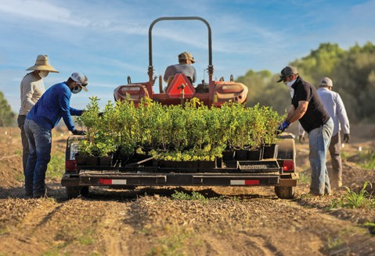

**6 River Partners *Fact Sheet***



**River Partners’ work and impact have been featured in hundreds of local, state, and national print, broadcast, and online news outlets, including The New York Times, Washington Post, National Public Radio, Associated Press, and Los Angeles Times, to name a few.**

# Fact Sheet

Mission: To create wildlife habitat for the benefit of people and the environment

Corporate Values: Environmental Stewardship, Community, Integrity, Leadership

Specialties: Restoration planning, riparian habitat restoration, monitoring & research, wildland establishment, land acquisition, agriculture, education & outreach

Innovations: Application of agricultural techniques to ecological restoration

Efficient large-scale habitat restoration with high wildlife values

Year founded: 1998 as “Sacramento River Partners” with a name change to “River Partners” in 2002 when our work expanded to the San Joaquin River

Geographic scope: Throughout the Central Valley, the Delta Region, the East Bay Region, Southern California and in Major River Systems in California, such as the Sacramento, San Joaquin, Feather, Tuolumne, Merced, Stanislaus, Mokelumne, Bear, Kern, Otay, San Luis Rey, Santa Ana, San Dieguito and Lower Colorado rivers

Statistics: Approximately 85 employees

>4 million trees and shrubs have been planted and monitored to date Nearly 20,000 acres have been put into restoration

Over 200 river miles restored

Over $150 million have been invested in restoration, conservation, and monitoring activities and directly into the communities where we work

Company Details: The organization is a non-voting membership corporation with a 11-member board of directors. California Landscaper’s License #858059

Donations: River Partners, a 501(c)(3) nonprofit public benefit corporation, accepts donations.

Private donations aid with developing and planning conservation projects, monitoring and research, securing matching grants, and supporting general operations. We have adopted “A Donor Bill of Rights” as a good faith policy for our supporters, as recommended by the Association of Fundraising Professionals. River Partners does not share or sell its mailing or donor list.

Awards: 2004 USFWS Environmental Restoration Leadership Award

2005 Governor’s Environmental and Economic Leadership Award

2007 James Irvine Foundation Leadership Award (John Carlon, Dr. Tom Griggs) 2008 Floodplain Management Association Award for Excellence

2009 Sustainability Award, CSU Chico

2014 Wildland Weeds Program Organization of the Year, Cal Invasive Plant Council 2020 Integrated Flood Management Award, Floodplain Managers Association

Leadership: Monroe Sprague, Board Chair Julie Rentner, President

# Organizational Experience

**FIRM SERVICES, CAPABILITIES AND ADVANTAGES**

In 1998, River Partners was founded by two conservation-minded farmers who believed that the fields of habitat restoration and agriculture could synergistically inform each other. Now a 501(c)(3)

nonprofit corporation, River Partners’ mission is to create wildlife habitat for the benefit of people and the environment.

**Founded in 1998, River   
Partners blends an entrepreneurial spirit, modern farming practices, and cutting-edge science to restore thousands of acres across California each year.**

We represent a new approach to protecting the environment, focusing on implementing on-the-ground restoration projects ranging from revegetation to channel reconstruction to levee breaching and barrier removal. Our restoration ecologists, biologists, and agricultural experts utilize a variety of tools to bring life back to riparian areas. Our success depends on the careful application of technology and science to ensure that projects provide benefits to both the environment and local communities.

With in-house expertise in riparian restoration ecology, agriculture, finance, project management, and monitoring, River Partners has forged successful partnerships with more than 50 public agencies, various levels of government, irrigation districts, global food/beverage and technology companies, nonprofit organizations. We have proudly partnered with several national refuge systems, a suite of federal agencies such as the U.S. Bureau of Reclamation, and the California Natural Resources Agency and myriad sub-agencies such as the California Department of Fish and Wildlife and Department of Water Resources to help them meet their own conservation goals.

**KNOWLEDGE AND EXPERIENCE**

We are well-versed in plant identification, seed collection and propagation methods, vegetation community design and plant alliances, as well as plant installation techniques and best practices for establishment and maintenance of seeds, cuttings, and container stock. Our Science and Operations teams work together closely to monitor and assess plant health across our restoration and maintenance sites. River Partners staff are familiar with the full suite of non-native and invasive plants that can become problematic weeds in restoration sites.

**COLLABORATIVE PROJECT IMPLEMENTATION**

Our native ecosystems interact at multiple spatial scales with municipalities, economies, ecosystems, water storage and delivery systems, and regional conservation initiatives. River Partners has cultivated constructive relationships with our resource and flood management agencies, as well as our local and regional governments.

**NATIVE SEED AND PLANT AMPLIFICATION AND NURSERY SERVICES**

Large quantities of native seed and plants of known genetic origin are not readily available in California and those that are often demand high prices. River Partners’ native seed and plant venture,

**Heritage Growers**, focuses on increasing the availability of native seed and plants and improving the quality and durability of habitat restoration projects to benefit state and federal agencies, native seed producers, and organizations and individuals implementing landscape-level habitat restoration projects.

# Project Experience

## THREE AMIGOS NON-STRUCTURAL ALTERNATIVE FLOOD MANAGEMENT PROJECT AT THE SAN JOAQUIN RIVER NATIONAL WILDLIFE REFUGE

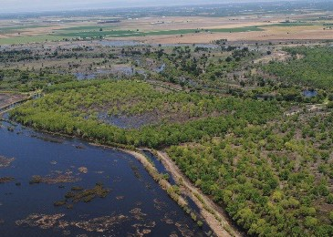

Client: Services: Acres: Ecotype: River:

Location:

U.S. Fish and Wildlife Service Planning, Design, and Restoration 3,166

Riparian Woodland, Seasonal and Perennial Wetlands San Joaquin River (Between River mile 87L and 77L)

(+/-) 18 miles West of Modesto, California, Stanislaus County

In 2002, River Partners received funding from the US Fish and Wildlife Service for Phase I to restore native riparian vegetation on 511 acres at the San Joaquin River National Wildlife Refuge (SJRNWR). Since then, through collaborative fundraising and planning, the restoration has grown to 2,500 acres of riparian forests and over 600 acres of managed seasonal and permanent floodplain wetlands (the restored area now totals 3,166 acres). The final step in this $40-million

* **Project results included a breeding pair of Bell’s vireo nesting and fledging their young in willows planted by River Partners—the**

**first time the endangered songbird had appeared in the Central Valley in 65 years**

* **Targeted habitat restoration has resulted in increased population resiliency to flooding and fires as well as the establishment of a new**

**population of endangered riparian brush rabbits**

effort is to breach the federal levees that separate the San Joaquin River from its historic floodplain. Project completion for the primary restoration and maintenance activities was reached in 2016.

River Partners worked with the Cal State Stanislaus Endangered Species Recovery Program (ESRP) to ensure planting designs met the habitat requirements of sensitive terrestrial species known to occur on the SJRNWR including federally threatened riparian brush rabbit and riparian woodrat. Additionally, we worked with avian ecology experts at Point Blue Conservation Science to design for the habitat needs of migratory birds, including special-status species such as Least Bell’s Vireo. With

the return of flood flows through planned levee breaches, anadromous fish will use these fields during spring floods. The USFWS Anadromous Fish Recovery Program (AFRP) provided funding to assist with the determination of the location of the planned levee breaches and how stream flows will move through the Refuge.

More important than the performance of the plantings is the wildlife response to this restoration. We’ve seen an increase in avian diversity and abundance on the Refuge following the implementation of restoration. Additionally, during the third project year, avian monitoring

by PRBO Conservation Science discovered a breeding pair of Bell’s vireo nesting and fledging young in willows planted by River Partners—the first time the endangered songbird had appeared in the Central Valley in 65 years. Targeted habitat restoration for riparian brush rabbit and riparian woodrat has resulted in increased population resiliency to flooding and fires as well as the establishment of a new population of riparian brush rabbits – bringing this species one step closer to recovery.

### Contact:

Kim Forrest, Refuge Complex Manager San Luis NWR Complex Phone Number: (209) 826 3508

Email: [kim_forrest@fws.gov](mailto:kim_forrest@fws.gov)

# Project Experience

## BEAR RIVER LEVEE SETBACK PROJECT

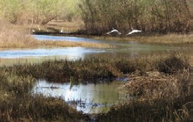

Client: Services: Acres: River(s):

Location:

Three Rivers Levee Improvement Authority

Planning, Design, Reporting, Restoration, Monitoring and Mitigation 625

Feather River and Bear River

13 miles South of Marysville, Yuba County

From 2006 to the present, River Partners designed, constructed, maintained, and monitored the riparian ecosystem restoration and mitigation components of the Bear River Setback Levee Project as a contractor to Three Rivers Levee Improvement Authority (TRLIA). The Bear River floodway capacity was increased through a levee setback.

* **The project expanded the floodplain of the Bear River by 325 acres by setting back**

**2.4 miles**

* **The habitat restoration and mitigation project that planted more than 120,000 native trees, seeded 250 acres of native grasses**
* **Upon identifying several archaeological sites, we worked with Tribal groups to plant a “living protective cover” of native blackberry, California rose, and poison oak**
* **We met terrestrial and mitigation habitat**

**requirements for multiple species, like the listed valley elderberry longhorn beetle**

This massive project expanded the floodplain of the Bear River by 325 acres by setting back 2.4 miles of the north Bear River Levee and degrading 1 mile of the eastern Feather River levee to reconnect the

floodplain, improve surface hydrology, and enhance ecosystem function. By integrating the project’s hydraulic design constraints, environmental mitigation requirements, and ecological objectives, River Partners designed and implemented a habitat restoration and mitigation project that planted more than 120,000 native trees, seeded 250 acres of

native grasses while ultimately minimizing long-term operations and maintenance of the expanded floodway. Prior to the project, River Partners was contracted by TRLIA to collect and propagate all necessary seed materials.

Several archeological sites were identified during project design and construction. River Partners worked with Native American groups to reach consensus on a “living protective cover” of native blackberry, California rose, and poison oak.

The restored ecosystem provides habitat for sensitive (listed) aquatic species, such as spring- run Chinook salmon, fall-run Chinook salmon, and Central Valley steelhead. The project also met terrestrial habitat requirements for the listed valley elderberry longhorn beetle (VELB), Swainson’s hawk, and neo-tropical migratory birds.

### Contact:

Paul Brunner, PE, Executive Director, TRLIA Phone Number: (530) 749-7841

Email: [pbrunner@co.yuba.ca.us](mailto:pbrunner@co.yuba.ca.us)

# Project Organization

**Management and Administrative Staff** oversee the day-to-day management of the organization, lead complex planning and stakeholder outreach efforts, manage high-profile and complicated restoration and land acquisition projects, fundraise, and provide all accounting and administrative services.

**Biology and Planning Staff** oversee the day-to-day monitoring and management of most projects and planning efforts, provide scientific quality control, manage partnerships with other science-based organizations, write restoration plans, attain all necessary permits for restoration projects, lead project monitoring and adaptive management efforts, and manage grants, contracts, and reporting.

**Field Staff** are responsible for developing logistics, implementing restoration projects, evaluating project success, and providing recommendations for improving techniques.

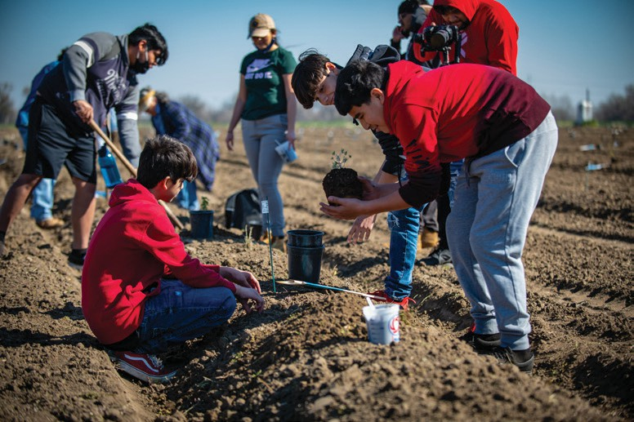

# Equipment

River Partners owns a collection of restoration equipment as listed below. River Partners owns its entire suite of IT equipment from personal workstations and laptops to servers and print stations at office locations across California.

River Partners leases a fleet of passenger vehicles, utility vehicles and heavy-duty trucks for day- to-day project work, and, when needed, will rent tractors, utility vehicles, trenchers, excavators,

and agricultural implements. A full range of equipment sizes and capabilities would be procured as demanded by the job.

**OWNED EQUIPMENT**

1. JD 5225 Tractor
2. JD 542 Farm Loader
3. JD 5055E w/ Loader
4. JD 5065E Tractor w/loader
5. Big W 1,100 Gallon Ball Water Tanker
6. Straddlebuggy Equipment Carrier
7. PBM Sprayers
8. John Deere 10’ Rotary Mower - Pull Type

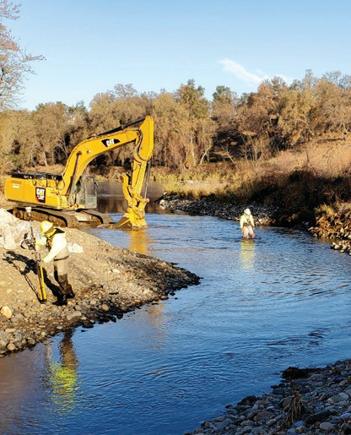

1. John Deere Diesel Gator XUV 855D
2. EZ Guide 500 GPS Unit w/ EZ Steer Attachment
3. Ridger
4. Rhino SE7A and SE8A 7’ & 8’ 3pt Rotary Mowers
5. Bubco Spraymiser 2000 folding wings 21gal
6. Bubco Spraydome 2034 Tow w/ 55gal
7. Truax FLXII-816RD Grass Drill
8. Del Rio #4 Generator
9. 1000 Gal Water Tanker
10. JD 5225 w/ JD542 loader (w/ Bucket & Forks)
11. 12’ Rhino Rotary Mower - Pull Type
12. Bush Hog 3210 10’ Rotary Mower
13. Rears 600A Flail Mower
14. PBM Sprayer Model ATT 55 12v skid
15. Trimble GEOXT Handheld GPS Receivers
16. Deweze 72” Mower
17. JD Gator XUV 855D DSL
18. 60ft Boom sprayer
19. 150 Gal Boom Sprayer (3 pt)
20. Model 84FH Rock Hound Shredder
21. JD 5065E Tractor w/loader
22. DH3272 Offset disk harrow
23. DH5110 10’ Rigid Single Offset Disk w/23 blades
24. FB940 Sickle Bar Mower

# Cost Proposal and Fee Schedule

**HOURLY LABOR BILLING RATES**

Please note that all hourly labor rates below are fixed for the initial contract term for FY2024 (7/1/23 – 6/30/24) and are subject to a 6% annual rate escalation for work performed in future years beyond the initial term. Rate table with annual escalation is provided in Exhibit A.

**STAFF MEMBER WAGE RATE**

President $188.52

Principal-in-Charge / Senior Director of Restoration $142.61

Director of Native Seed and Plant Program, Heritage Growers $166.73

Associate Director of Science $129.99

Project Manager / Senior Ecologist $103.73

Restoration Ecologist / Biologist $70.86

Field Manager $88.66

Field Foreman $68.41

Field Technician (non-prevailing wage) $40.88

Operational Engineer (Group 1 state Prevailing Wage rate) $144.68

Operational Engineer (Group 2 state Prevailing Wage rate) $130.64

Laborer (Group 3 state Prevailing Wage rate) $124.43

Laborer (Group 4 state Prevailing Wage rate) $110.66

Driver On/Off Hauling (Prevailing Wage rate) $52.59

Project Analyst $89.74

**VEHICLE BILLING RATES**

Please see the per-mile and per-hour rates below for vehicles that are expected to be necessary and relevant under this primary agreement, which could include a variety of On-Call Services at various locations over the next several years. As with the wage rates outlined above, the detail of vehicle needs and per-mile and/or per-hour cost of vehicles needed for projects will be provided as specific SOW’s arise under this primary agreement.

Office Vehicles $0.93 per mile

Field Vehicles $1.46 per mile

Tractors $95.23 per hour

Gators $27.53 per hour

**DAILY EQUIPMENT BILLING RATES**

Please note that all equipment daily rates below are fixed for the initial contract term for FY2024 (7/1/23 – 6/30/24) and are subject to a 6% annual rate escalation for work performed in future years beyond the initial term.

|  |  |
| --- | --- |
| **OWNED EQUIPMENT** | **DAILY RATE** |
| Hand tools | $20.60 |
| Weed trimmers (line trimmers, brush cutters, etc.) | $51.50 |
| Chain saws / hedge trimmers | $77.25 / $51.50 |
| Backpack herbicide sprayer | $51.50 |
| Herbicide application equipment (power sprayer, booms, etc.) | $220.24 |
| Big W ball water tanker | $225 |
| **ADDITIONAL EQUIPMENT** | **DAILY RATE** |
| Mower (small, walk behind) | $154.50 |
| Brush cutter (tow/push attachment) | $290.46 |
| Riding Mower | $234.84 |
| Brush chipper (large) | $506.76 |
| Small backhoe/loader (20-30 hp compact) | $370.80 |
| Small water truck (2000 gal) | $821.94 |
| Large water truck (up to 4000 gal) | $803.40 |
| Large backhoe (60-97 hp) or skidsteer | $655.08 |
| Dump truck (large, 10-15 cy capacity) | $834.30 |
| Aquatic harvester | $1,174.20 |
| Other equipment rented as required | Lowest rental cost available + 20% |

# Key References

### Chris Harper, Project Leader

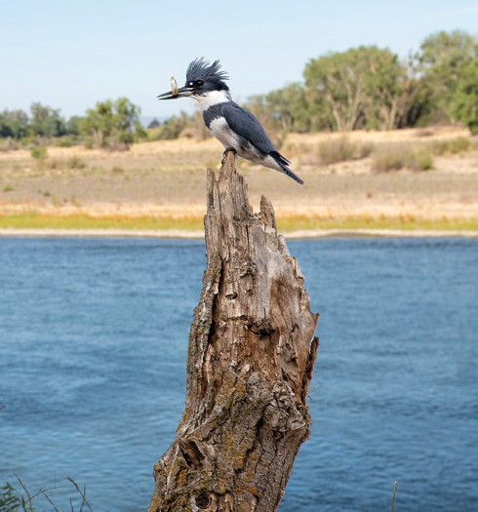San Luis National Wildlife Refuge

U.S. Fish and Wildlife Service

P.O. Box 2176

7376 S. Wolfsen Road

Los Banos, California 93635

(209) 826-3508

[chris_harper@fws.gov](mailto:chris_harper@fws.gov)

**Daniel Strait, Program Manager** Central Valley Project Improvement Act Habitat Restoration Program and

Central Valley Project Conservation Program

U.S. Bureau of Reclamation, MP-152 2800 Cottage Way

Sacramento, California 95825

(916) 978-5052

[dstrait@usbr.gov](mailto:dstrait@usbr.gov)

### Molly Ferrell, Senior Environmental Scientist

Long-term Habitat Management Program Delta Ecosystem Enhancement Section Division of Multi-Benefit Initiatives Department of Water Resources

P.O. Box 942836

Sacramento, CA 94236-0001

916-820-7800

[molly.ferrell@water.ca.gov](mailto:molly.ferrell@water.ca.gov)

# Exhibit A: Billing Rates with 5-year Escalation

### Santa Clara Valley Habitat Agency “On-Call Land Management Services”

Please note that all hourly labor rates below are fixed for the initial contract term for FY2024 (7/1/23 – 6/30/24) and are subject to a 6% annual rate escalation for work performed in future years beyond the initial term. Rate table with annual escalation is provided in Exhibit A.

|  |  |  |  |  |  |
| --- | --- | --- | --- | --- | --- |
| **Position** | **2023/2024** | **2024/2025** | **2025/2026** | **2026/2027** | **2027/2028** |
| President | $188.52 | $199.62 | $211.59 | $224.29 | $237.74 |
| Principal in Charge/Senior Director of Restoration | $142.61 | $151.17 | $160.24 | $169.86 | $180.05 |
| Director of Heritage Growers | $166.73 | $176.73 | $187.33 | $198.57 | $210.48 |
| Associate Director of Science | $129.99 | $137.78 | $146.05 | $154.81 | $164.10 |
| Project Manager / Senior Ecologist | $103.73 | $109.95 | $116.55 | $123.54 | $130.95 |
| Restoration Ecologist / Biologist | $70.86 | $75.12 | $79.62 | $84.40 | $89.46 |
| Field Manager | $88.66 | $93.97 | $99.62 | $105.58 | $111.92 |
| Field Foreman | $68.41 | $72.52 | $79.62 | $84.40 | $89.46 |
| Field Technician | $40.88 | $43.34 | $45.94 | $48.69 | $51.61 |
| Operational Engineer 1 | $144.68 | $153.36 | $162.56 | $172.31 | $182.64 |
| Operational Engineer 2 | $130.64 | $138.47 | $146.77 | $155.57 | $164.90 |
| Landscape/Irrigation Laborer 3 | $124.43 | $131.50 | $138.78 | $146.07 | $153.35 |
| Landscape/Irrigation Laborer 4 | $110.66 | $117.29 | $124.32 | $131.77 | $139.67 |
| Laborer (Driver On/Off Hauling) | $52.59 | $52.59 | $52.59 | $52.59 | $52.59 |
| Project Accountant | $89.74 | $95.12 | $100.83 | $106.88 | $113.29 |

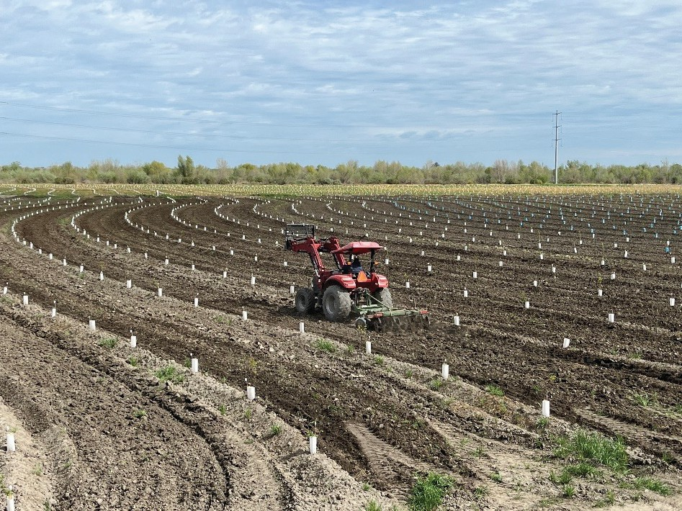

**We planted more than 75,000 native trees and plants at our Hidden Valley Ranch restoration project, which sits along the state’s second-largest waterway, the San Joaquin River.**

